Homework 1  
  
A.  
autoData <- read.csv("C://Users//Seinu//Documents//Auto.csv",na.strings = "?")

B.  
> typeof(autoData)

[1] "list"

> class(autoData)

[1] "data.frame"

C.

> dim(autoData)

[1] 397 9

D.

> autoData = na.omit(autoData)

> dim(autoData)

[1] 392 9

E.

> ls(autoData)

[1] "acceleration" "cylinders" "displacement" "horsepower" "mpg" "name" "origin"

[8] "weight" "year"

F.

> attach(autoData)

The following objects are masked from autoData (pos = 3):

acceleration, cylinders, displacement, horsepower, mpg, name, origin, weight, year

> plot(cylinders,mpg)  
> plot(mpg,cylinders)

Wasn’t sure if cylinders was x or y so i did both

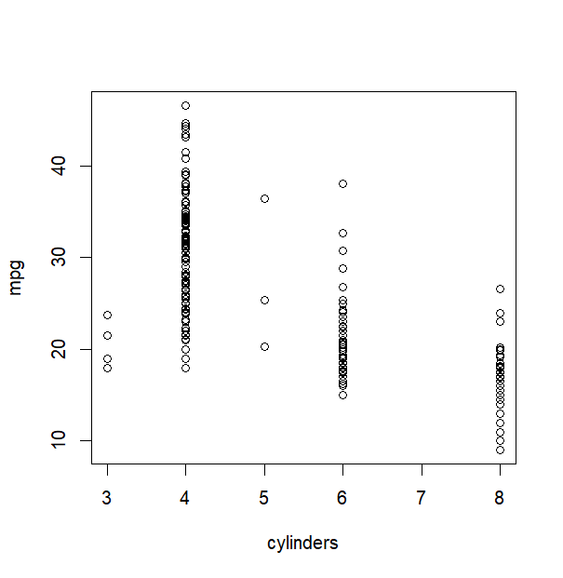

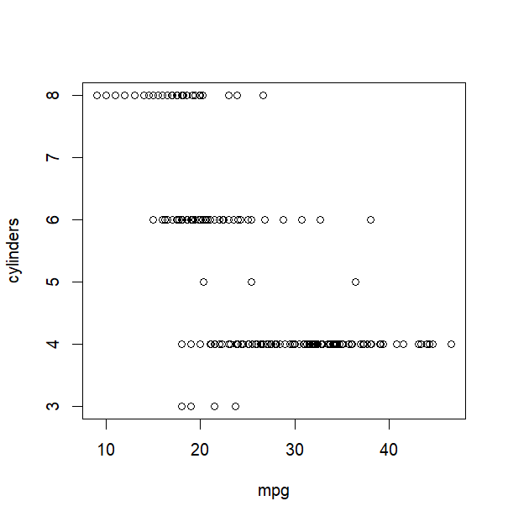  
G.

cylindersFactor = factor(cylinders)

plot(mpg,cylindersFactor,col="green")

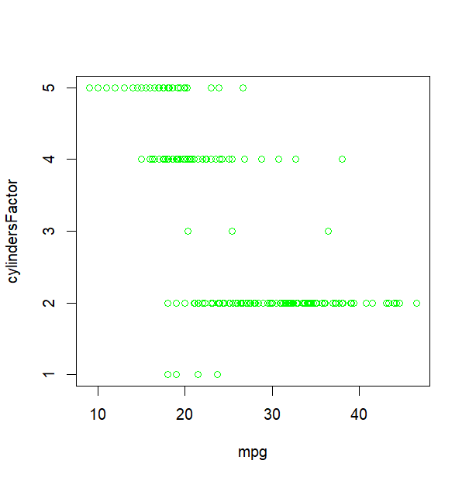

H.

hist(mpg,col="green",breaks=10)

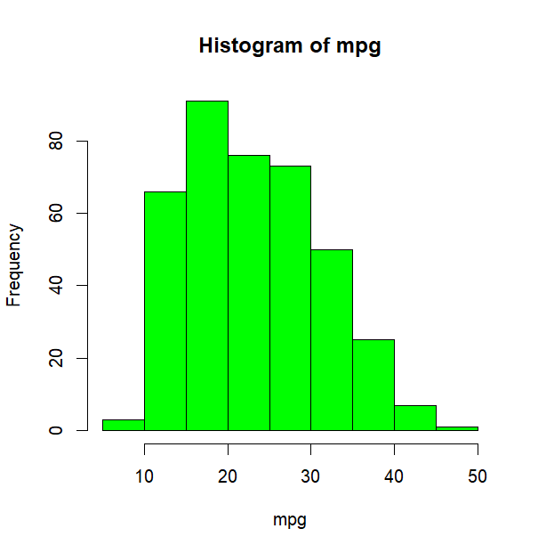

I.

pairs(select(autoData,'mpg','displacement','horsepower','weight','acceleration'))

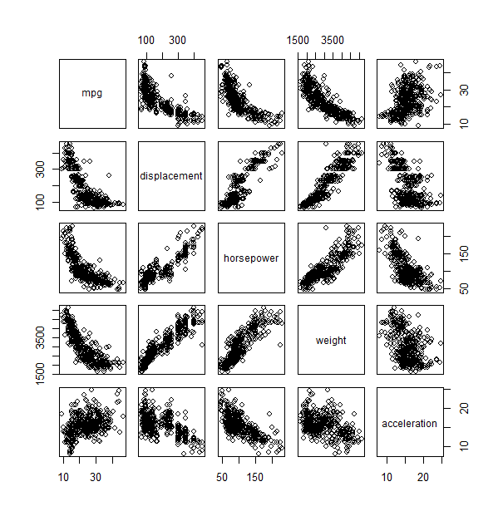

J.

newAuto = filter(autoData,grepl("chevrolet|ford|toyota|bmw|volkswagen",name))

> df = data.frame("Mean" = c(mean(newAuto$mpg),

+ mean(newAuto$weight),

+ mean(newAuto$horsepower),

+ mean(newAuto$acceleration)),

+ "Variance" = c(var(newAuto$mpg),

+ var(newAuto$weight),

+ var(newAuto$horsepower),

+ var(newAuto$acceleration)))

> rownames(df) = c("Mpg","Weight","Horsepower","Acceleration")

> df

Mean Variance

Mpg 22.62030 4.984148e+01

Weight 2965.22556 7.413998e+05

Horsepower 101.77444 1.269509e+03

Acceleration 15.60376 7.649304e+00